______________________________________________________________

UM-SJTU JOINT INSTITUTE

SINGALS AND SYSTEMS

(VE 216)

______________________________________________________________

LABORATORY REPORT

LAB 1

LTI Systems

|  |  |  |
| --- | --- | --- |
| Name: **Weikai Zhou** | ID: **518021911039** |  |
| Date: 28 June 2020 |  |  |

1. **Objectives**

* To become familiar with the laboratory equipment: power supply, signal generator, digital oscilloscope, computer data acquisition system (Scope Connect).
* To review basic concepts of linear time-invariant systems.
* To illustrate several possible ways to determine the impulse response of a physical system from measured data.
* To use linearity, time-invariance and impulse response to compute the output of an LTI system when the input is a step, a pulse, or a more complicated signal. You will compare these calculations with actual measurements.
* To measure the frequency response of an LTI system and compare against theory.

1. **Theoretical background**

An RC circuit is used so that the computations are easy and physically meaningful. The same procedures can be applied to much more complicated systems.

* 1. **RC circuit**

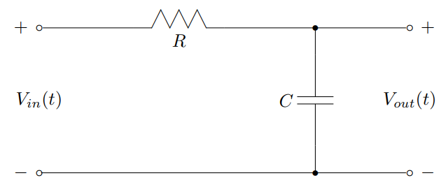The RC circuit shown below is an example of a simple LTI system (Figure 1). Of course, there are many other LTI systems that do not involve circuits at all.

Figure 1. RC circuit

We will take the system input to be the voltage $V_{in}(t)$, while the system output is the voltage, $V_{out}(t)$, dropped across the capacitor. Notice that these voltages, in general, will be functions of time, .

* 1. **When is a linear circuit a linear system?**

Using Kirchoffs current and voltage laws, one can easily derive a differential equation model of the RC-circuit in Figure 1, namely

$$RC\frac{dV_{out}(t)}{dt}+V_{out}\left(t\right)=V_{in}\left(t\right). (1)$$

Appealing to basic knowledge of ODEs from a sophomore level math course, the total solution is seen to be

$$V_{out}\left(t\right)=V_{0}e^{-t/RC}+\int_{0}^{t}{\frac{1}{RC}}e^{-\frac{t-τ}{RC}}V_{in}\left(τ\right)dτ, t≥0, (2)$$

where the initial condition at time zero is $V_{out}\left(0\right)=V_{0}$. It is very easy to verify that $V_{out}\left(t\right)$ is a linear function $V_{in}\left(t\right)$ if, and only if, $V_{out}\left(0\right)=V_{0}=0$, that is, the initial voltage on the capacitor has to be zero. This point is emphasized because you will have to assure this in the laboratory by either waiting for the charge to decay on the capacitor or by shorting the capacitor with a wire.

**Reassuring remark**: We will learn how to deal comfortably with nonzero initial conditions when we study the Laplace transform. For the time being, it is important to realize that we are assuming zero initial conditions when our models arise from a differential equation.

* 1. **Impulse response**

The impulse response, $h\left(t\right)$, of an LTI system is, by definition, the output response when the input of the system is a delta function, $δ\left(t\right)$. Of course, the delta function is a mathematical idealization. In practice, $h\left(t\right)$ can be well approximated by the response of the system when the input is a pulse of very short duration (compared with the response time of the system) and unit area, such as $p_{∆}\left(t\right)=\frac{1}{∆}\left(u\left(t\right)-u(t-∆)\right)$ for ∆ > 0 sufficiently small.

Note that in order to keep the area of the pulse equal to unity, the amplitude has to increase as the pulse duration gets shorter. Often, this is a problem in a practical system as a large voltage pulse may fry an amplifier, for example. One way to get around this is to use linearity and realize that if the input is scaled by “*b*”, then the output will be scaled by “*b*” as well. Consequently, if the measured response is divided by “*b*”, an approximation of the impulse response is obtained.

* 1. **Step response**

For any LTI system the output can be expressed as

$$y\left(t\right)=x\left(t\right)*h\left(t\right)=\int_{-∞}^{+∞}{x\left(τ\right)h\left(t-τ\right)dτ=}\int_{-∞}^{+∞}{x\left(t-τ\right)h\left(t\right)dτ}, (3)$$

where $x\left(t\right)$ denotes the input and $*$ denotes the convolution operation. The output resulting when the input is a unit step function, $x\left(t\right)=u(t)$, is called the unit step response. Simple manipulation leads to

$$y_{step}\left(t\right)=u\left(t\right)*h\left(t\right)=\int_{-∞}^{∞}{h\left(τ\right)u\left(t-τ\right)dτ}=\int_{-∞}^{t}{h\left(τ\right)u\left(t-τ\right)dτ}+\int_{t}^{∞}{h\left(τ\right)u\left(t-τ\right)dτ}, (4)$$

which, because the unit step function is equal to 1 for $t-τ>0$ and equal to 0 for $t-τ<0$ step response simplifies to

$$y_{step}\left(t\right)=\int_{-∞}^{t}{h\left(τ\right)dτ}. (5)$$

By taking the derivative of $y_{step}\left(t\right)$ with respect to $t$, we obtain, by the fundamental theorem of calculus,

$$\frac{dy_{step}\left(t\right)}{dt}=\frac{d}{dt}\int_{-∞}^{t}{h\left(τ\right)dτ}=h\left(t\right). (6)$$

Thus the impulse response can be computed from the unit step response by calculating the derivative of the step response with respect to time. This is a useful observation because it is sometimes easier to apply a step input to a physical system than it is to apply (an approximation of) an impulse.

We now have two ways of determining the impulse response from data. A third way will be hinted at a little later.

1. **Experiment procedures**

**Setup** (some parts not needed in Proteus software)

* Function generator: Utility 🡪 Output Setup 🡪 Load 🡪 High Z

1. Trigger Mode 🡪 Basic

* Oscillator: Trigger Menu 🡪 2. Edge Trigger (Rising Edge)

3. Trigger Settings 🡪 DC Coupling

* RC circuit: R = 1 KΩ, and C = 1 *µ*F

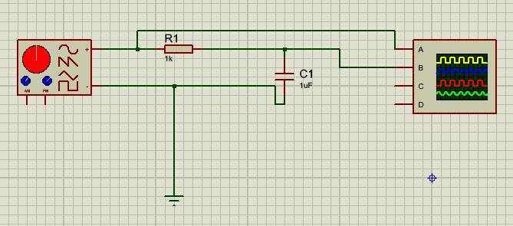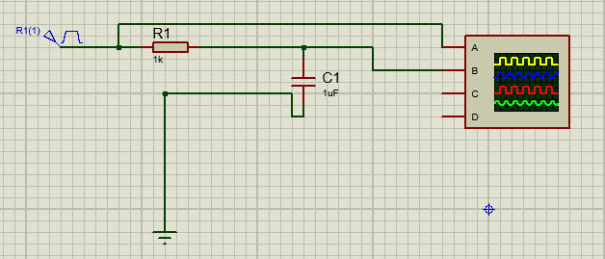The circuit we build is shown below (Figure 2).

1. Pulse response (b) Other response

Figure 2. Circuit in Proteus 8

* 1. **Step response**
* Function generator:

Square wave Vpp: 1V frequency: 100Hz

* Oscillator:

CH1: 200mV/div CH2: 200mV/div Time: 2ms

* Compare the results with the ideal case
  1. **Pulse response**
* Function generator: Pulse frequency: 100Hz
  + 1. Width: 1ms A: 100mV
    2. Width: 0.5ms A: 200mV
  1. **Ramp response**
* Function generator:

Ramp Vpp: 100mV frequency: 100Hz

* 1. **Sine response**
* Function generator: 10 Vpp

|  |  |  |  |
| --- | --- | --- | --- |
| Frequency (Hz) | Vout / Vin | Time Shift | Phase Shift |
| 50 |  |  |  |
| 500 |  |  |  |
| 5k |  |  |  |

* Compare the results with ideal case

1. **Experiment results & Error analysis & Discussion**
   1. **Step response**

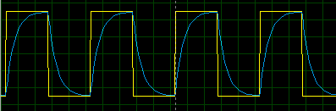The step response is shown below (Figure 3).

Figure 3. Step response

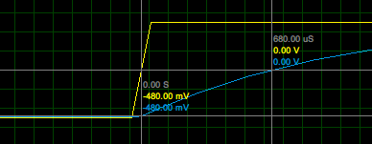The yellow signal is the input and the blue signal is the output. Using cursor (Figure 4), we can get $τ=$ 680 $μ$ s.

Figure 4. Cursor for step response

And theoretically,

$$V_{out}=y_{step}=1-e^{-\frac{t}{RC}},$$

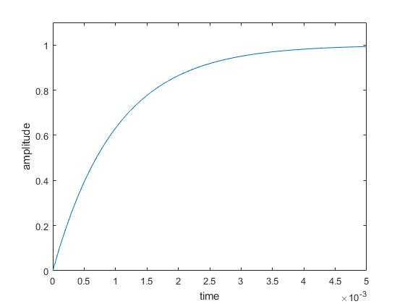and if we plug in *R* = 1*k*Ω, *C* = 1*µ*F, we can use Matlab to get the theoretical output (Figure 5).

Figure 5. Theoretical step response

We can find that they have almost the same shape and we can get that theoretically, $τ_{theoretical}=$ 693 $μ$ s. The relative error between $τ$ and $τ_{theoretical}$ is

$$\frac{693-680}{693}×100\%=1.88\%,$$

which is smaller than 5%. Therefore, we can assume that the real one corresponds with the theoretical one. And the minor difference may be because of the precision of the oscillator.

* 1. **Pulse response**

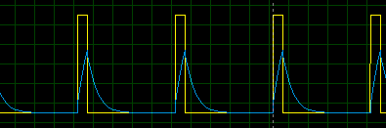The pulse response is shown below (Figure 6 & 7).

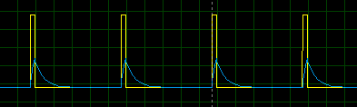Figure 6. Pulse response with Width 1ms, A 100mV.

Figure 7. Pulse response with Width 0.5ms, A 200mV.

The yellow signal is the input and the blue signal is the output. Since in real life we cannot have the ideal pulse input, we can only minimize the width of the input signal. The theoretical response is shown below (Figure 8). And the experimental one is similar to the theoretical one.

Figure 8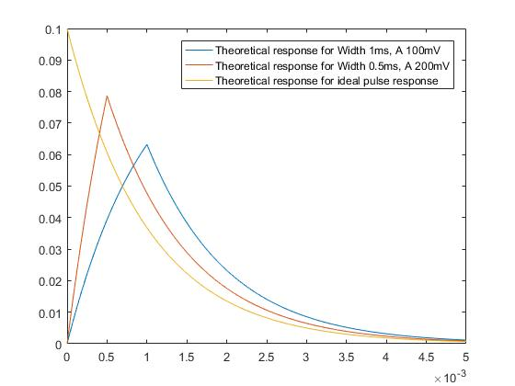. Theoretical response

* 1. **Ramp response**

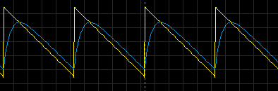The pulse response is shown below (Figure 9).

Figure 9. Ramp response

The yellow signal is the input and the blue signal is the output.

* 1. **Sine response**

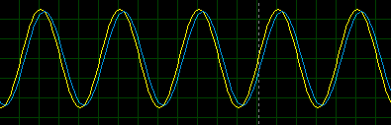The sine response is shown below (Figure 10 & 11 & 12).

Figure 10. Sine response for 50 Hz

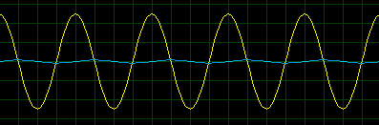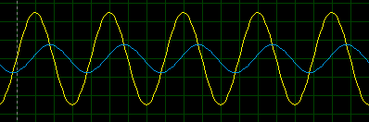Figure 11. Sine response for 500 Hz

Figure 12. Sine response for 5k Hz

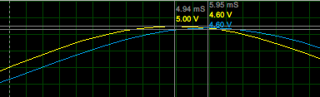And using cursor, we can get the following figures (Figure 13 & 14 & 15).

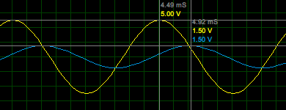Figure 13. Cursor for 50 Hz

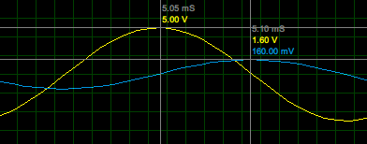Figure 14. Cursor for 500 Hz

Figure 15. Cursor for 5k Hz

Based on the data form the cursor, we can form the following table (Table 1).

|  |  |  |  |
| --- | --- | --- | --- |
| Frequency (Hz) | Vout / Vin | Time Shift (ms) | Phase Shift (◦) |
| 50 | 4.60 / 5.00 = 0.92 | 5.95 – 4.94 = 1.01 | -18.18 |
| 500 | 1.50 / 5.00 = 0.30 | 4.92 – 4.49 = 0.43 | -77.40 |
| 5k | 0.16 / 5.00 = 0.03 | 5.10 – 5.05 = 0.05 | -90.00 |

Table 1. Experimental data for sine response

The phase shift is calculated as follows with the first one as an example:

$$-2πf_{c}×\left(Time shift\right)×\frac{180}{π}=-2π×50× 1.01×{10}^{-3}×\frac{180}{π}=-18.18.$$

From pre-lab, we have the following theoretical data (Table 2).

|  |  |  |  |
| --- | --- | --- | --- |
| Frequency (Hz) | Vout / Vin | Time Shift (ms) | Phase Shift (◦) |
| 50 | 0.9540 | 0.9689 | -17.4406 |
| 500 | 0.3033 | 0.4019 | -72.3422 |
| 5k | 0.0318 | 0.0490 | -88.1768 |

Table 2. Theoretical data for sine response

Then, compare Table 1 and Table 2, we can get the relative error as follows (Table 3).

|  |  |  |  |
| --- | --- | --- | --- |
| Frequency (Hz) | Vout / Vin | Time Shift | Phase Shift |
| 50 | 3.56% | 4.24% | 4.24% |
| 500 | 1.09% | 6.99% | 6.99% |
| 5k | 5.66% | 2.04% | 2.07% |

Table 3. Relative error for sine response

The highest error is 6.99%, and this may be because of the precision of the oscillator and human error when doing cursor. But the most data are within 5%, therefore, we may consider the real one corresponds with the theoretical one.

1. **Conclusion**

From this lab, we became familiar with the laboratory equipment: power supply, signal generator, digital oscilloscope, computer data acquisition system; we reviewed basic concepts of linear time-invariant systems; we illustrated several possible ways to determine the impulse response of a physical system from measured data; we used linearity, time-invariance and impulse response to compute the output of an LTI system when the input is a step, a pulse, or a more complicated signal; we compared these calculations with actual measurements; we measured the frequency response of an LTI system and compare against theory.

In step response part, we compare the experimental one with the theoretical one and get the 1.88% relative error, which is smaller than 5%. Therefore, we may consider that the real one corresponds with the theoretical one.

In pulse response part, since in real life we cannot have the ideal pulse input, we can only minimize the width of the input signal. And the experimental one we get is similar to the theoretical one.

In ramp response part, we get the experimental figure for the output.

In sine response part, we calculated the Vout / Vin, time shift and phase shift, and compared them with the theoretical values. The highest relative error is 6.99%, which may be because of the precision of the oscillator and human error when doing cursor. But the most data are within 5%, therefore, we may consider the real one corresponds with the theoretical one.

1. **Reference**

[1] Lab+1+Manual_v2.pdf

[2] PreLab1_SU2020.pdf